BLOGPOST - How to succeed on Kickstarter

The Complete Guide To Succeeding on Kickstarter In 2017 - Everything We Learned in Raising $1.5M
Words : Marc Barros
A lot has been written about how to succeed on Kickstarter. We wrote our own guide back in 2014 after our first campaign. But three years, three campaigns, and $1.5M later, the Kickstarter playbook required in 2017 is different. To all the creatives thinking about crowdfunding, this is everything we have learned.
What's Changed
Crowdfunding is more sophisticated. Another way to say this, crowdfunding takes more work.
It's not that you can't have a mega hit. Looking at the Top 100 projects you can see that Kickstarter is still turning out some massive campaigns.
But as you dig further you begin to realize that crowdfunding has shifted from community to e-commerce. Yes the community behind Kickstarter is still amazing, but the mechanics of being successful on the platform has changed. It's no longer a "post and they will come" strategy. Instead you have to become much more granular about your approach.
Especially if you are making a physical product, the headwinds are just stronger in 2017 versus prior years. Blame it on the Amazon expectation of "i want it shipped yesterday" or the negative perception that failed crowdfunding projects have left with the media. The overall intrigue about a new project that people can "pre-order" is just less interesting than it was.
To be clear, this isn't a Kickstarter problem. It's a consumer shift to wanting more, for less, and faster. The quality bar on new products continues to rise while consumer willingness to invest in the new has diminished. Yes crowdfunding has had some mega disasters, but it has also enabled thousands of creators to fulfill their dreams.
PLATFORM DECISIONS
Why Crowdfund
Our thesis from 2014 has not changed three years later. Manufacturing is still expensive and crazy hard. Although it has gotten cheaper to engineer new products, the cost to manufacture has not changed. Tooling, testing, parts, packaging, and labor are still heavy fixed costs that require pre-payment. Which means that crowdfunding is more than just a market validation requirement....it's a financial requirement.
The trend towards repeat crowdfunders is comforting as a company looking to build great products for many years to come. Even with initial market success companies like Peak Designs, Pico Brew, Pebble, Lomography, Biolite, Kano, and Baron and Fig have come back to Kickstarter with future projects. Crowdfunding is no longer a go to market strategy reserved for "yet to start" companies.
When to Crowdfund
We prefer to wait until after we have a solid prototype and a clear understanding for how to produce the product. We always work with a supplier in advance to ensure that we understand our cost and confidence to manufacture.
What was different for this campaign is that we had an existing product line in the market. We assumed that the introduction of new products would stop the sales of our existing products. This assumption turned out to be false.
This learning taught us that going forward we need to bring new products to market faster. We should be crowdfunding products sooner and not waiting to have multiple new products at the same time.
Why We Chose Kickstarter
They have won the crowdfunding race, their community is amazing, and they have an internal team that works directly with their creators. They also happen to have an avid community willing back to creative projects, which is exactly the Moment customer base.
We also considered going direct, seeing that Glowforge raised over $30M on their own. In the end we decided that as a small team we were better off spending time on the campaign and not trying to recreate our own pre-order e-commerce experience. Kickstarter has optimized the experience to maximize a campaign, it's something not to be underestimated.
PRE-CAMPAIGN DECISIONS
We believe these are the most important pre-campaign decisions to consider.
Length Of Time
More time equals more money. Pre-orders after the campaign usually drop significantly from your Kickstarter rate so the longer your campaign runs the bigger the number. The only reason to make the campaign shorter (say 30 days) is if you require the money in your pocket to start tooling / manufacturing. Kickstarter provides the funds 14 days after the campaign ends, which means if you need that money earlier you will want to consider that in the timeline you select.
Our first two campaigns were 30 days. This third campaign was 60 days. Thankfully we are three years into building Moment so our partners were willing to start once the campaign was funded even though the money had yet to arrive in our bank account.
Number of Products
In our third campaign we introduced multiple new products at the same time. We debated this heavily, but ultimately decided we had to introduce Moment 2.0 together or we risked bifurcating our message across multiple Kickstarter campaigns. Ultimately it made it harder for people to understand what the campaign was about and how to back it.
The only caveat to the number of products is be careful about adding more colors. Visual variance between products always sounds easy upfront but once you get into manufacturing it is incredibly painful. Your volumes get split into small quantities often putting you under minimum order quantities and then post campaign you end up with a mix of the wrong colors/materials.
With Moment 2.0 we did offer two visual looks (wood and black) both really this is the same black case with the color/variance being applied at the end of the product line. We learned a lot of painful lessons last time in making both a white and black case.
Amount To Raise
Picking this number is hard. It is both a financial and an emotional decision.
From a financial POV manufacturing and purchasing inventory are expensive. You have to consider all of the costs involved so you don't successfully reaching your funding goal, which ends up not being enough money to ship what you promised. We built this cost calculator to help us understand the real costs in bring these new products to market.
Backer Level Calculator
From an emotional POV, Kickstarter is about momentum. The higher the initial number the longer it may take to cross. In our first two campaigns we immediately passed the funding line, giving people confidence that the project was a go. This time the $500K in funding we required was the right number but created backer friction as people wondered if the project would be funded. Between $300-500K we heard from a lot of potential backers who were going to wait until we crossed the funding line.
Pick too low and you won't have enough money to deliver. Choose to high and you risk losing momentum and worsening conversion rates.
Number of Backer Levels
Three years ago we said keep it simple. We appreciated how Studio Neat and Peak Designs kept their levels to less then five, making it easy for backers to pick. In our third campaign we decided to change this decision.
We came to realize a few limitations in keeping it simple.
- You leave money on the table. Although Kickstarter really is e-commerce their backer levels are not organized that way. Instead of letting people mix and match different offerings within your campaign, you are forced to pre-pick levels and their contents. Therefore you miss significant sales by not being able to provide "add-ons" during the campaign. Pico Brew has the most clever solution we've seen, creating a pledge calculator to help people figure out how much to pledge to receive add-ons.
- Delivering to everyone at the same time is harder. By only having a few levels, you are forced to deliver all of your pledges at the exact same time. Manufacturing is always a staged process, therefore build your pledges around delivery timelines.
- Early pricing levels improve conversion rates. Pricing levels that expire are annoying but apparently but effective. Especially if you are going to spend advertising dollars to drive your campaign, having a price that expires soon does improve conversion rates. If not people will just wait until you are over the funding line. Every person that visits the page and doesn't back the project is generally a lost customer.
In the end we ended we created 4 core levels, three of which we included an early ship and a regular ship date. But because our campaign had two different products across four different devices we had 25 total levels.
Pricing Your Backer Levels
Calculating your pricing levels requires you to understand your manufacturing costs and product margins. We ended up building another tool that helped us calculate margins, pricing, and to forecast the overall campaign. We removed our actual numbers but you are welcome to download and use this tool for your own campaign calculations.
Backer Level Calculator
Adding Your Logistics Costs
Don't skip this step. In addition to the pricing exercise above you need to figure out your true logistics costs, by country, to deliver each backer level.
The cost comes down to two questions; which countries are you going to support and how are you going to handle taxes?
To figure out which countries to support find a logistics partner, work out a relationship, and get a final rate card so you know what it costs to ship each backer level. Generally the right partner will be able to advise on which countries to support.
Next you can decide how you want to handle taxes. One method is to leave the cost up to the customer. The risk is that they don't know they need to pay these taxes and are surprised when they get a call/email from customs. This can result in upset customers and abandoned packages. The benefit to this path is the backer level cost is lower and therefore conversion rates should be higher.
The second method is to wrap these costs into the per unit price of each backer level. This is our preferred path as the user experience is better and it reduces the number of future emails. Kickstarter does let you set a price by country so you can copy our template below and calculate the total cost of logistics per country.
This spreadsheet took us multiple days to complete.
Shipping Cost Calculator
Note: in order to calculate taxes you need to get an HS code for each product as the taxes vary by country and product value. We use Duty Calculator to calculate our import fees.
CREATING THE CAMPAIGN
We used to believe that succeeding on Kickstarter was about the why. Simone Sinek is right, “People don’t buy what you do, they buy why you do it.” But in 2017 consumers are digesting more and more content which means they have less time to understand the why and instead want to quickly understand the what to their own "why this makes my life better."
Start With The Script
We always start the creative process by writing the script. It forces you to be succinct in messaging the why, what, who, and how. Our script can be found here.
From the script you can see we like to break the video into the following sections:
1. Inspiration
Showing is always more powerful than telling. Rather than jumping straight into the product details we like to show people using our new products in their every day life, combining beautiful imagery with a simple introduction about our beliefs. We have always found the power of demonstration should never be underestimated.
Campaign videos that inspired us this time:
2. Who We Are
A short introduction to Moment and why we're doing this project. It makes you personable.
3. What And How It Works
Being succinct is really hard. It always takes us dozen of re-writes to summarize what the product does and why people should care. Rule of thumb is if you were in a bar explaining your product, that is the language you should use in the video. Naturally in a noisy environment you are forced to simplify. Do the same here.
4. How It's Made
Provide people with an inside look into the journey you followed to arrive at your crowdfunding campaign. The depth of this section can vary depending on your product, but with Moment we wanted to show the detail that went into designing our products. Both from an engineering and design perspective we wanted people to have confidence in answering the question: Why should I back Moment?
5. The Ask
At the end provide people with a clear and simple ask. We prefer asking for one thing: back the project.
Creating The Video
From the script we start listing out what visuals would go with the words. Even if you can't hold a camera or edit a video, you can start listing out what scenes/actions match your words. Like a good informercial you want to show a diversity of use cases.
To help, we identify 3-4 tribes of people that will be the basis of the video, such as the outdoor tribe. By identifying a tribe of people the visual details become much easier to brainstorm, such as the location, people, attire, etc. This work generally doesn't cost money as your friends and family want to see you be successful and are willing to help be a part of your video.
Where you do spend money is shooting and editing. At Moment we do the work within the team, but if you are outsourcing this, focus on a team of less than three people. One to direct and two to shoot. Usually one of the three also serves as the editor. The cost to shoot and edit is significantly cheaper then asking an outsourced group to also create the script and direct the video.
Some additional things to consider...
- The camera operators don’t also have to be the editor. You can hire people to shoot the content you need, which will cost you about $500-1K per day. To ensure consistency it does help to have the same camera operators and camera equipment.
- Editing will be the most expensive phase. If you outsource, this can run you $2-4K for a fully edited piece.
- Music is critical for setting the mood and something you should select before you start editing. We used Music Bed and spent $900 on the song. Be sure you have a license to use this song on all of your content or you run the risk of getting into a legal battle.
- Get feedback at the script stage! Don’t wait until the video is done or your re-editing costs will be super expensive.
- Don’t forget about the photos and gifs. You will need images to tell your story with the press, on your campaign page, and on your website. You want a mix of product only shots (i.e. beauty shots on white backgrounds), the product within the context of its environment, and people using your product.
Campaign Page Structure
In 2017 you want to follow e-commerce best practices. If you scroll through the recent top projects you begin to see a trend where the top of the campaign page is all about backing the project, attempting to make purchase simple. Then the rest of the page is more detail about the why, what, how, and when.
We spent a lot of time arranging and re-arranging the contents of the Kickstarter page. We also spent a lot of time during the campaign making changes based on customer feedback. Something to know is that Kickstarter has a character limit of 35K characters and everything is counted in that number, including images. Kickstarter pages are meant to be long, just realize you could run out of space if you use a lot of images.
You can see our final page layout here.
PRE-LAUNCH PRIORITIES
A lot goes into the campaign before it's live. The first 48 hours is still everything in creating the momentum you need.
Create A Plan
We actually create this brief before we start anything associated with Kickstarter. We're placing it here with the pre-launch topics but really start with a master brief to outline what you need to do before, during, and after the campaign. As your teams grow briefs become powerful ways to create and execute a project.
This is our original Kickstarter brief.
Build Your Email List
Email still works and the bigger your list is the more people you can share the campaign with. When we started Moment we only had our friends and family on the list. If you can, start sending consistent pre-campaign emails so they can follow your progress in leading up to the big day.
Talk To Influencers Early On
Our process three years ago was the same as with this campaign. We identified a small group of people who were nice enough to provide early product and campaign feedback. That group grew to about 50 influencers before the campaign launched who got to see and tryout the Moment 2.0 prototypes.
Mobile photography is a little easier because Instagram has already created a massive community filled with our exact customer, but if your product category doesn’t include a connected community you need to find opinions that backers will respect.
The importance of these influencers isn’t to help you reach more backers. Really, their impact is to help you make a better product, which is why you want to reach these opinion leaders very early in the development process. Even when you are on a piece of paper or with 3D printed prototypes you want to start building these relationships.
Connect With Press
PR coverage in 2017 for your pre-order campaign is significantly harder. For the first time we heard several, "we don't cover crowdfunding campaigns" responses. Blame it on the failed campaigns, but the only reason we received press coverage this time around was because of our past experience in delivering on two previous campaigns.
Regardless of the temperament to cover crowdfunding you want to follow these do's and don'ts.
Do
- Make a press page. Ours is here.
- Visit with editors in person. Ideally send them a short note introducing yourself, including the dates you are in town, and asking if they have 15 minutes to see a demo. Let them know you are introducing a new product and in person let them know how (ie crowdfunding).
- Provide the page, photos, url, and launch story at least 3-4 days in advance of the campaign launching.
- Create a master list of all the online publications you think your backers read. Organize this list into Tier A (top 10-15 publications), B (second group of 15-20) and C (the rest). Focus on Tier A for visits.
- Find an introduction. Cold emails to editors rarely work. The guys behind Soma wrote a great post about how they found connections to their editors
- Provide them a simple embargo announcement date/time so they know when the story can go live.
Don't
- Put crowdfunding in the title of your email. They will delete without opening it to hear what you have to say.
- Be a jerk or write long emails. Editors get thousands of emails so be succinct and to the point.
- Hit multiple people at the same publication with the same email. Find the right person and send them a personal note.
- Ask them to sign an NDA. Editors never do.
- Ask to proofread their story. You can't control what they write so hopefully it's positive.
- Reach out after the campaign launched. Once it's public the novelty of the announcement is over. You can reach out with follow-on stories but not to say, hey will you cover us?
- Don’t be a jerk if they say no. If you are successful you will be working with these same editors for years to come.
Create Your UTM Codes
Kickstarter has gotten a lot better at providing data. Within Kickstarter you can create custom reference links. And you can setup a Google Analytics account that provides all the data required to understand traffic and conversions.
Unfortunately we got our UTM code structure wrong in the beginning of the campaign so our data was terrible until we corrected the problem about mid campaign. UTM structure is highly dependent to how you organize Google Analysts, but here is the spreadsheet we built.
UTM Template
RUNNING THE CAMPAIGN
Running a Kickstarter campaign is a lot of work. In some ways it's a lot easier than 2014, but in a few ways it's harder. Rather than go through everything in grave detail here what's new to executing in 2017 and here is what hasn't changed.
What Hasn't Changed - It's Still A Hustle
- Press coverage drives traffic and conversions.
- Momentum in the first 48 and the last 48 hours are everything. We did 32% of our results in 4 days of the campaign.
- Big share buttons within the campaign help. The Kickstarter magic algorithm takes "shares" into account.
- Consistent updates are important to drive more awareness and backer engagement.
- Be timely on comments and messages. It improves conversion rates.
- Campaigns are long and you need news, content, and tactics that keep the conversation going.
- Being featured within Kickstarter definitely helps.
- Early pricing levels give people a reason to back right now.
What Has Changed - It's More Like E-commerce
- Kickstarter messages can be connected to a standard email tool. It makes responding manageable.
- Google Analytics integration makes tracking easier and more accurate.
- Custom referral tags within Kickstarter are much better, enabling you to better understand what is and isn't converting.
- The number of "solicitation emails" has gone way up. Kickstarter is a platform now, which means service providers will hit you up all the time offering you amazing, fantastic results.
- Paid acquisition must be part of your strategy if you want a large outcome.
Paid Advertising
The biggest change in running a campaign is the reality that paid acquisition is required for a mega hit. Most of the biggest campaigns won't tell you this, but they are using a paid acquisition strategy, generally Facebook.
We used to think a paid strategy was a dishonest way to go. We were naive to think three years ago that Kickstarter was just about building community and if you did that well you would receive the financial support you needed to launch your project. In 2017 the world has changed. It's not just a Kickstarter thing, but globally consumers have higher and higher expectations. They expect free shipping in 48 hours, they are distracted by more content than ever before, they have shrinking attention spans, and they are more cynical to the failed projects before. All of his means you have to become hyper targeted and how you reach potential customers.
You can see from our latest campaign that Facebook was our top referral source.
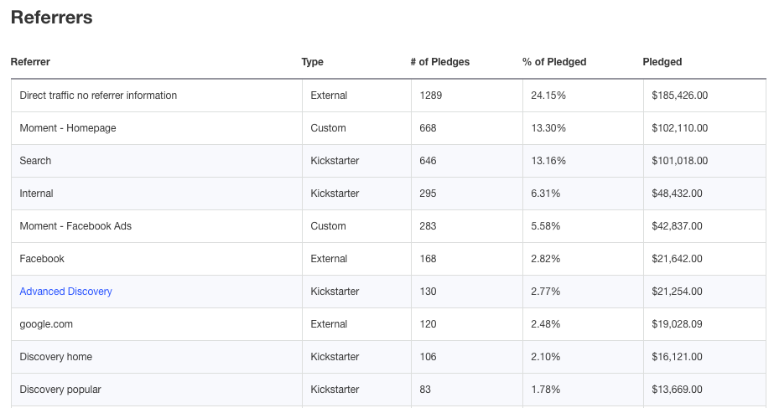

There are Kickstarter specific advertising companies. They are very expensive, asking up to 10% of your total funding. What they don't tell you is that the secret to their success is the Facebook audiences they have built. Over time they have built their own custom audiences within Facebook of people likely to back Kickstarter projects. Supposedly there are about 12-15M people who are consistently active on Kickstarter and these advertising groups have found a way to manually create a look alike audience that matches this group of people. They have also setup a bunch of different "Kickstarter" Facebook Groups to help improve their audience. Yes they've built their own tools to handle the manual conversion tracking process, but most of all they have figured Facebook audiences. Each project they successfully fund improves their audience, making them better and better at it.
If you are going to advertise on your own here is what we learned:
- Kickstarter doesn't allow a conversion pixel so you basically have to track conversions by hand.
- The first 5 days and last 3 days are everything. These are the days when advertising converts best.
- Tiered pricing levels improve conversion rates so the ads can include a scarcity message.
- You want to tinker text, headline, description, and photo. The headline was the most important using words like pre-order, scarcity, etc.
- Your own Kickstarter type badges over photos can work, especially if you are featured or if the campaign is about to end.
- Ads for photos and words trumped video ads. Video ads got clicks but brought in 1/10th of the pledges.
Here are our top 5 performing ads:
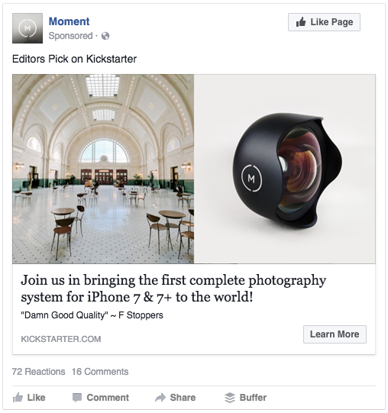 | 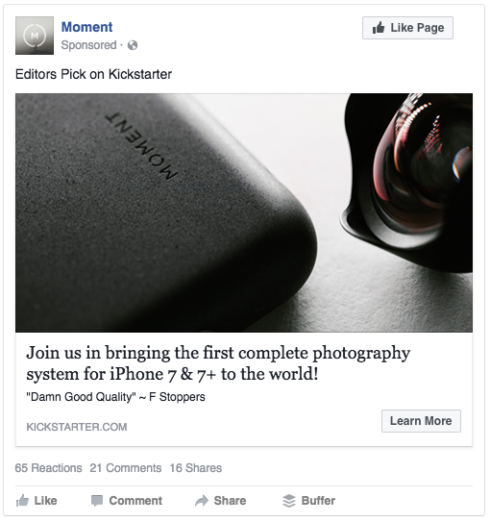
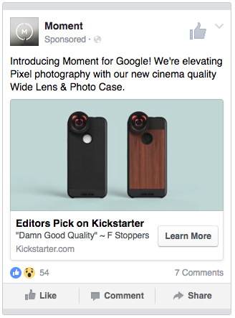 | 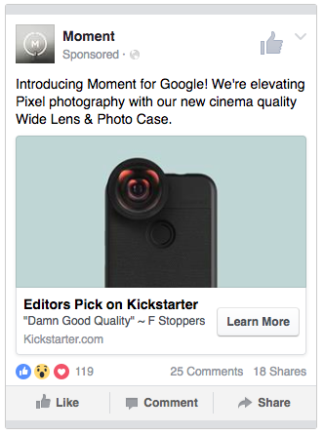
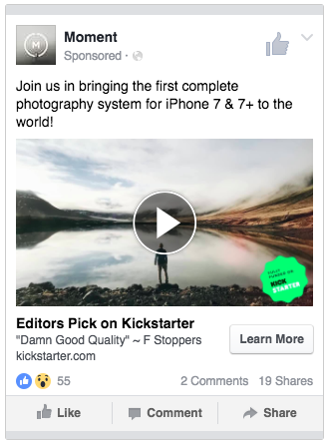 | 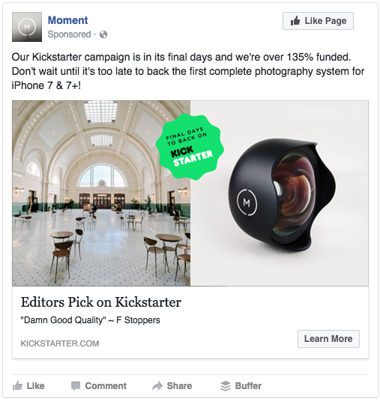
If you want to see other FB ads just spend time on Kickstarter and then go over to Facebook. You'll start seeing ads.
ALL OUR DATA
To give back to the community here is the data that Kickstarter provides on the back end as well as some interesting learnings from Google Analytics.
Kickstarter drove 36% of our pledges, down from our last campaigns where this was closer to 43%. The first 48 hours and the last 48 hours accounted for 32% of our pledges.
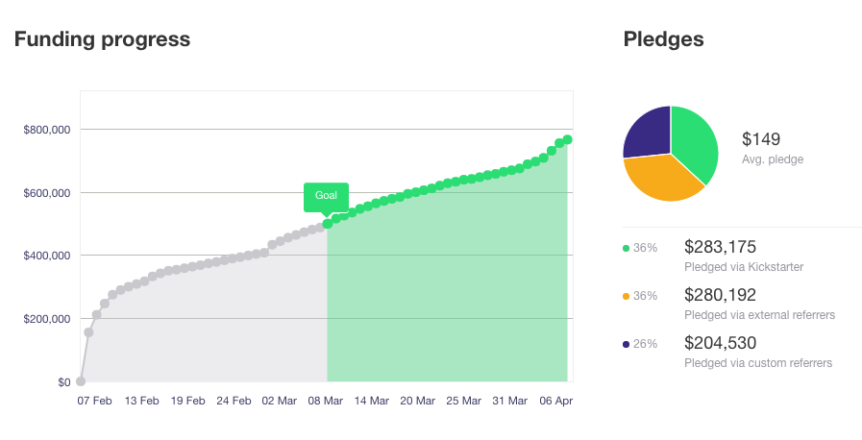

Our top referral sources isn't totally accurate because we did a poor job of setting up UTM codes and referral links within Kickstarter. We figured out how to use them about half way through the campaign.
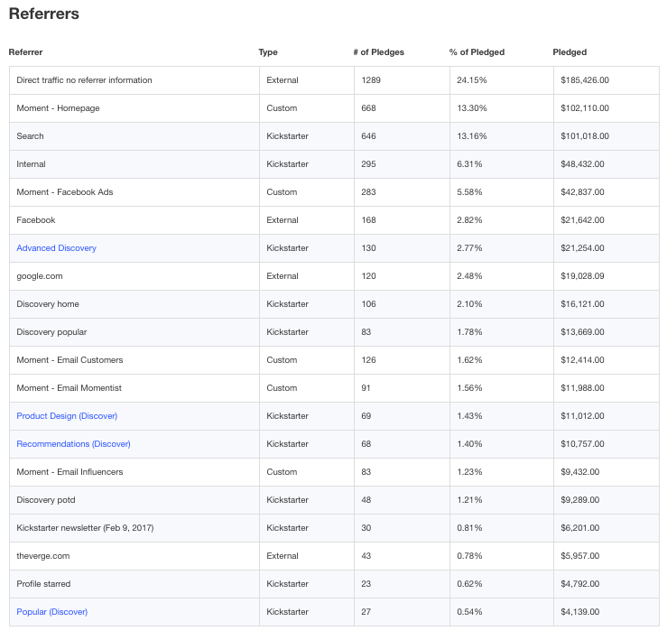

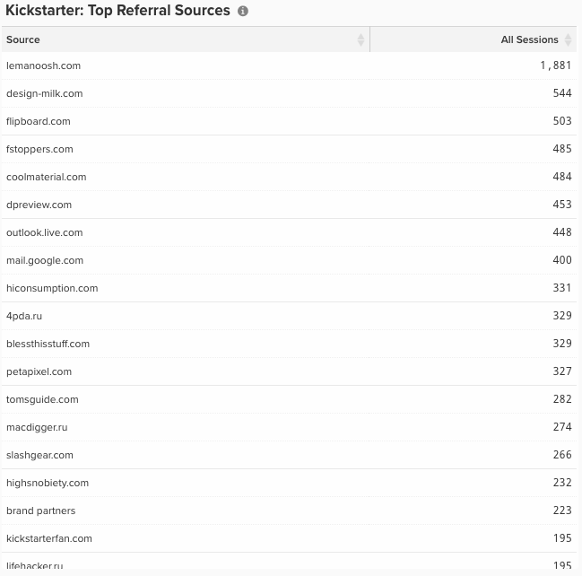

The biggest difference this campaign compared to the last one was the amount of pledges driven by press. Two years ago it was a lot easier to be covered for crowdfunding. In 2017 it's significantly harder, which means you have to do a lot more leg work on your own.
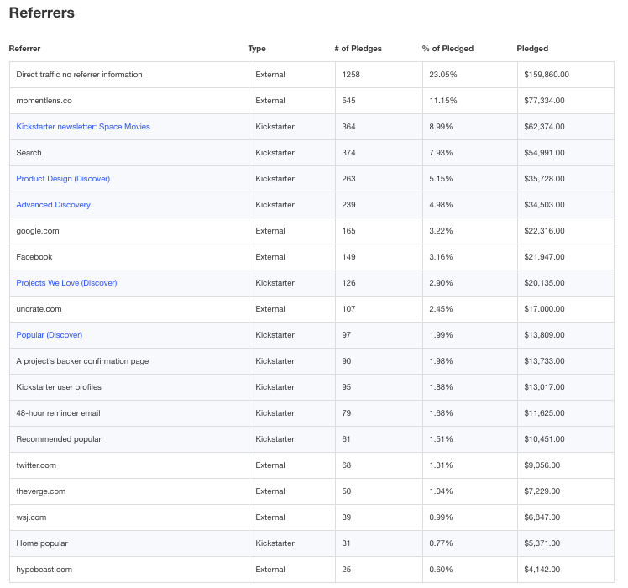

Our page and video got more traffic lats campaign. Comparing video plays both inside and outside of Kickstarter we had 24% less plays. Granted we used a YouTube embed on our own website this time instead of the Kickstarter embed. YouTube brought in another 38K views.
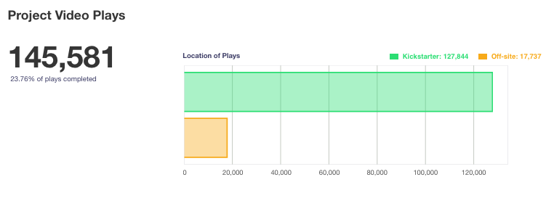

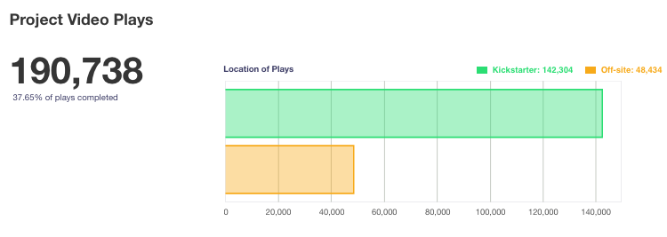

One of the most surprising learnings is the number of repeat visitors a campaign receives. We assumed visitors bought on first visit or didn't buy at all. This shows that retargeting really is important for a campaign.
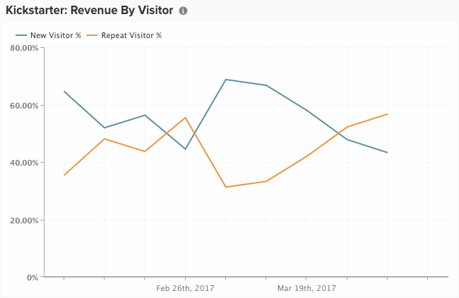

You can see from sessions and pledges that the first few days is critical and the last few days is also a frenzy to back the project. You have to be ready with your plan from the minute the campaign goes live.
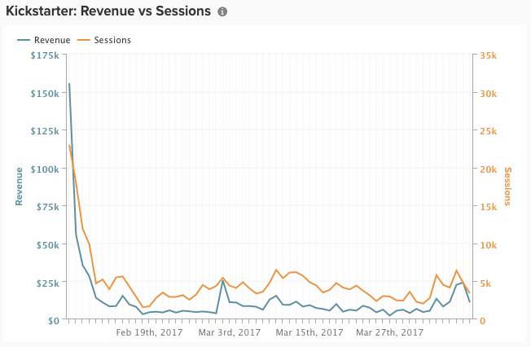

From an e-commerce point of view you can never have enough data about conversion rates. Conversion rates in the US were much higher than international because we included shipping and taxes in the cost to pledge. The higher purchase costs lower conversion rates.
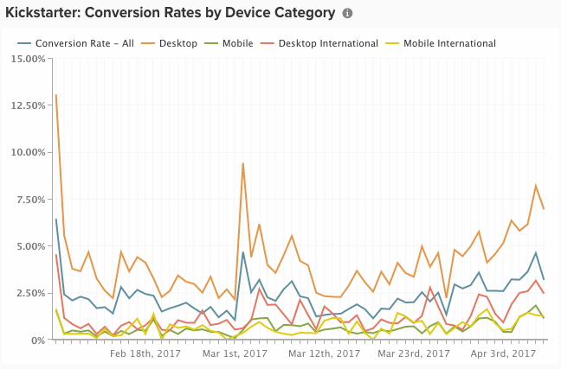

At Moment we divide the team into content and shopping. Our UTM tracking was wrong through the first half of the campaign so the data below is only accurate for the back half of the campaign. Most interesting is we used Help Scout as our email customer support tool. We began tracking links we shared in email and came to realize that customer service was one of our best converting channels. Don't underestimate the value in quality customer service to impact the campaign.
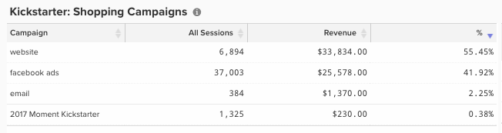

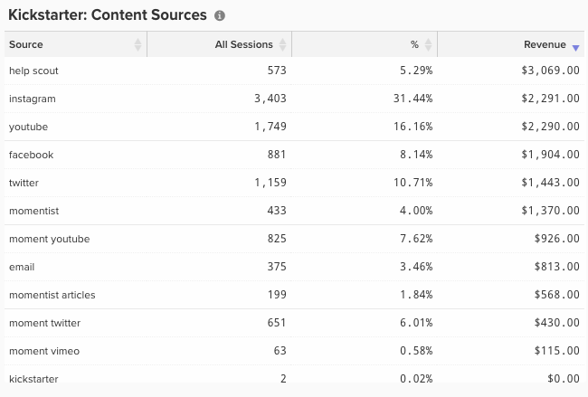

CONCLUSION
At the end of the day, crowdfunding is all about the backers. They are the backbone of this movement and the reason you can turn a dream into a reality. Interacting with them on a minute by minute base is an exhilarating experience that you may never experience again as a company.
We can’t say thank you enough to the 14,704 Moment backers who are supporting us on our journey.
Thank you!
RESOURCES
Here is a list of all the resources we used that are listed through out the article.
Inspiration
These projects inspired us when creating Moment.
3rd Party Tools
Help Scout - email based customer service.
Klaviyo - email marketing tool.
Music Bed - license music for crowdfunding videos.
Google Analytics - track the traffic and conversions.
Google URL Builder - make your UTM urls.
Bitly – a URL shortener that cleans up the long urls you are making with Google.
Facebook Advertising - self explanitory
KickTraq – a tool to track your own project and research previous ones.
Moment Made Tools
Kickstarter Brief
Video Script Template
Backer Level Calculator
Shipping / Tax Cost Calculator
UTM Template

From <https://www.shopmoment.com/momentist/the-complete-guide-to-succeeding-on-kickstarter-in-2017-everything-we-learned-in-raising-1-5m>

